Little Melba’s Journey to the Ocean

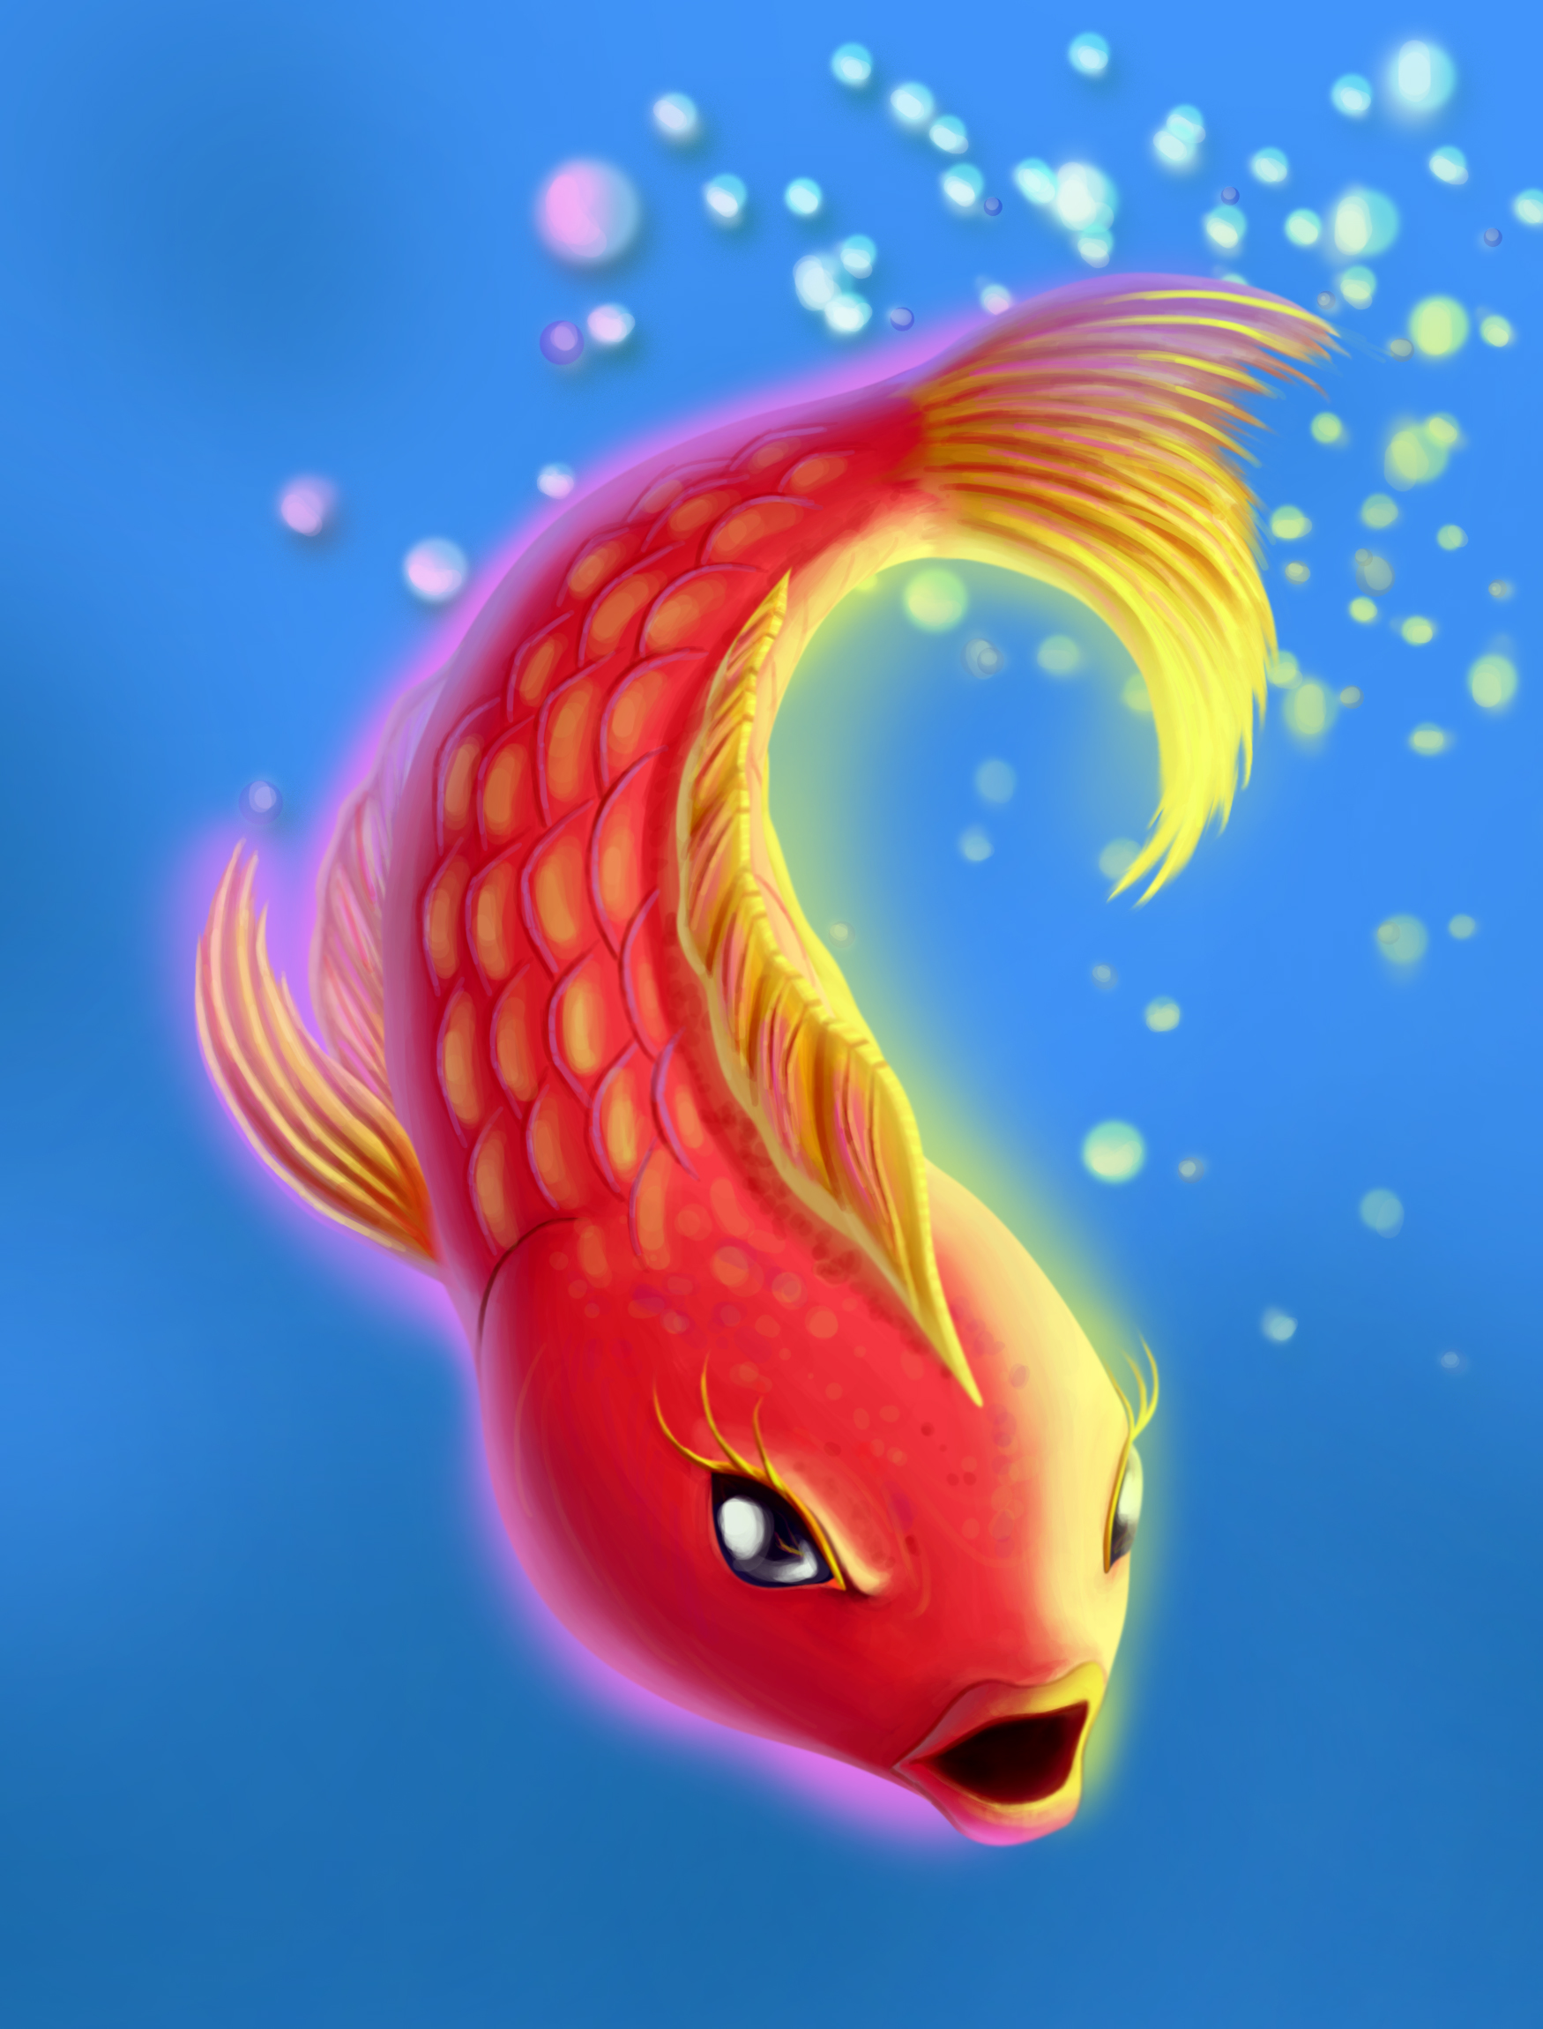

By Achim Mohssen-Beyk
Copyright © 2012 by Achim Mohssen-Beyk
All rights reserved under international and Pan-American copyright conventions. Written permission must be secured from the publisher to use or reproduce any part of this book, any characters and drawings either in print or electronically, except for brief quotations in book reviews or news articles.
Dedication:
This book is dedicated to my children Lea and Shirin for believing in me and for their love, a source of hope and happiness.
Little Melba’s Journey:

Chapter one - Melba leaves the familiar

Chapter two - Melba and the frog family

Chapter three - Melba, the crab and a lizard

Chapter four - Melba learns from a deer

Chapter five - Melba is prepared but not worried

Chapter six - Melba’s dream

Chapter seven - Melba faces the Pelican

Chapter eight - Melba reaches the ocean

Chapter nine - Melba and the Heron

Chapter 10 – Melba finds her new world

Chapter one - Melba leaves the familiar
It was the longest winter night at the bottom of the ocean. An old fish gathered 12,000 of her children and grandchildren around her and began to tell them a story:
Once upon a time a little red fish named Melba lived with her mother in a small creek high up in the mountains. Their home was behind a black rock where they slept under the leaves of a water Lilly at night. Melba longed for a long time to see the moonlight shine once in their home. From morning till evening, Melba and her mom swam after each other. Sometimes they swam among other fish and rapidly darted in and out of small crevices. Melba was the only child. Of the 10,000 eggs which the mother had laid, only she had survived.
Melba had been for several days deep in thought and had talked very little. She was listless, swam slowly behind her mother around the pond and did not play with the other fish. Her mother thought that Melba was sick and would soon be well. In reality, Melba’s sickness was really something else!
It was one early morning before sunrise when Melba woke her mother up and said:"Mother, I want to talk to you."
Half-asleep, the mother responded: "Melba, this isn't the time to talk. Save your words for later. Shouldn’t we go swimming and find a breakfast?"
"No, Mother! I don’t want to go swimming anymore. I am not hungry. I must leave here."
"Do you really have to leave?" asked her mother.
"Yes, Mother, I must go." said Melba.
"Just a minute! Where do you want to go at this hour of the morning?" worried her mom.
"I want to go see where the stream ends”, replied Melba impatiently. “You know, Mother……, I've been wondering where the end of the creek is. I haven't been able to find the answer for this for months.
I didn't sleep a wink all night, thinking about it. At last, I decided to go and find where the stream ends by myself. I want to know what's happening in other places."
The mother laughed, "When I was a child, I used to have thoughts like that. But, my dear, a creek has no beginning and no end. That's the way it is. The creek just flows and never goes anywhere."
"But mother, isn't it true that everything comes to an end? Nights end, days end, weeks, months, years ..." said Melba.
"Forget such big talk," interrupted the mother - "Let's go swimming. Now is the time to swim, not talk."
Melba called out impatiently: "No, Mother, I'm tired of this swimming around, I want to set out and see what's happening elsewhere. Maybe you think someone taught me these ideas but believe me, I have had these thoughts for a long time. Of course, I've learned many things here and there. For instance, I know that when most fish get old, they complain that they wasted their life. I want to know if life is simply for swimming around in a small place until you get old and nothing else, or is there another way to live in the world?"
When Melba finished the mother with a sigh : "My dear child, are you crazy? World! ... World! What is this other world! The world is right here where we are. Life is just as we have it..."
Just then, a large fish approached their home and said: "Neighbour, what are you arguing about with your child? Aren't you planning to go swimming today?"
Hearing her neighbour's voice, the mother came out of the house and said, "What happened to this world! Now children even want to teach their mothers something!"
“How so? "asked the neighbour.
“Listen to the places Melba wants to go!" replied the mother. "Saying over and over again I want to go see what's happening in the world. What big talk is that?"
"Little one," said the neighbour, "let's see. Since when have you become a scholar and philosopher without telling us?"
"Madam," answered Melba, "I don't know what you mean by 'scholar' and 'philosopher,' I've just gotten tired of these swimming around. I don't want to continue this meaningless stuff and pretend to be happy until one day I wake up and see I've become old, but still know as little as I do now."
"Oh, what kind of talk is this?" exclaimed the neighbour.
"I never thought my only child would turn out this way," said the mother. "I don't know what evil person put such thoughts into my sweet baby’s mind."
"No one put me up to anything," said Melba. "I have a mind, and intelligence and understanding. I have eyes and I can see."
"Sister," said the neighbour to Melba's mother, "do you remember that twisted-up snail?"
"Yes, you're right," said the mother. "He used to push himself on my baby. God knows what I would do to him if he still would be around!"
"That's enough, Mother," said Melba. "He was my friend."
"Friendship between a fish and a snail?" said the mother, "I've never heard of such a thing before!"
"And I've never heard of a fish and a snail being enemies," replied Melba. "But you all drowned the poor fellow."
"This is all in the past," said the neighbour.
"You brought up the subject from the past yourself," said Melba.
"It served him right to be killed," said the mother. "Have you forgotten the things he used to say everywhere he went?"
"Then," said Melba, "kill me too since I'm saying the very same things."
To make a long story short, the arguing voices attracted the other fish. Melba's words angered everyone.
One of the old fish asked, "Did you think we'd pity you?"
"That one just needs a spanking," said another.
"Go away you all," said Melba's mother. "Don't you touch my child."
Another of them said, "Madam, if you don't raise your child correctly, you must expect it to be punished."
The neighbour said, "I'm ashamed to live next to you."
Another said, "Let's do to the little fish what we did to the old snail before it causes more trouble."
When they tried to grab the little red fish, her friends gathered around and took her away from the quarrel.
Melba’s mother beat her head and chest and cried, "Oh, my baby is leaving me. What am I going to do? What a curse has fallen upon me!"
"Mother, don't cry. Cry for all the old fish who stay behind." said Melba.
"Don't get smart, little one!" shouted one of the fish from afar.
"If you go away and afterwards regret it, we won't let you come back," said a second.
"These are useless thoughts of the youth. Don't go," said a third.
"What you think is wrong with this place?" said a fourth.
"There is no other world. The world is right here. Come back!” said a fifth.
"If you turn reasonable and come back, then we'll believe you really are an intelligent fish," said a sixth.
"Wait, we've gotten used to having you around ..." said a seventh.
The mother cried, "Have mercy on me. Don't go! Don't go!"
Melba didn't have anything more to say to them. Her desire to find the answer to find out where the creek ends was stronger.
Several friends of the same age accompanied Melba as far as the waterfall. As they parted, Melba said, "My friends, I hope to see you again. Don't forget me!"
"How would it be possible to forget you?" asked the friends.
"You've opened our eyes. You've taught us many things that we had not even thought about before. We hope to see you again, wise and fearless friend. Good luck.”
Melba waved her friends goodbye as she swam away. Even though she was sad, she wondered of the things she may encounter along her journey.
Dare to question things and discover Life. Do what you are passionate about if it is positive, even if others want to hold you back and say you can’t. Of course no one has to leave home like Melba did to learn more about life. Don’t be shy to imagine your future and look positively at life; it is a journey for each of us.

Chapter two - Melba and the frog family
After a leaving her friends Melba swam down the creek where she felt the current pick up speed. She had arrived at the waterfall when she plunged into a pond full of water. At first, Melba lost her balance and did not know what happened to her but soon she began to swim and circle around the pond. She had never seen so much water collected in one place.
She discovered thousands of tadpoles that were wiggling close to the edge of the pond. They laughed when they saw Melba," Look at her! What kind of a creature are you?"
Melba looked them over thoroughly and said, "Please don't insult me. My name is Melba. Tell me your names so that we learn each other knowing.
"We call one another tadpole," replied one of the tadpoles.
"We come from noble background," said another.
"You can't find anyone prettier than us in the whole world," said another.
"We aren't ugly and bad looking as you," said another one.
Melba said, "I never imagined you would be so self-centered. That's all right. I'll forgive you since you're speaking out of ignorance."
In one voice the tadpoles demanded, "Are you saying we're stupid?"
"If you weren't ignorant," replied Melba, "you'd know that there are many others in the world who are pleased with their appearance. You don't even have names of your own."
The tadpoles became very angry. But since they knew the little fish spoke truthfully, they changed their tone and said, "really, you're wasting words! We swim around the world every day from morning till evening, but except for ourselves and our father and mother, we see no one. Yes, there are tiny worms, but they don't count."
"You can't even leave the pond," said Melba. "How can you talk about traveling around the world?"
"What! Do you think there is a world other than the pond?" exclaimed the tadpoles.
"At least," responded Melba, "you must wonder where this water comes from and what things are outside of it."
"Outside of the water!" exclaimed the tadpoles, "Where is that? We have never been outside of the water! Haha ...haha ...You're crazy!"
Melba also started to laugh. She thought it would be better to leave the tadpoles to themselves and go away, but then changed her mind and decided to speak to their mother.
"Where is your mother?" asked Melba.
Suddenly, the deep voice of a frog made Melba jump aside. The frog was sitting on a rock at the edge of the pond. She jumped into the water, came up to Melba and said:
"I'm right here. What do you want?"
"Hello, Great Lady," said Melba.
The frog responded "Strange creature, now is not the time to show off. You've found some children to listen to you and are talking big words. I've lived long enough to know that the world is this pond. The ponds edge is only for grown ups to catch some flies for food. Mind your own business and don't lead my children astray."
"If you lived a hundred years," said Melba, "you'd still be nothing more than an ignorant and helpless frog."
The frog got angry and jumped towards Melba. Melba flipped quickly and fled like lightening, stirring up sediment and worms at the bottom of the pond. She continued to swim downstream without looking back. Melba felt sorry for what she had said to the frog as she felt it was not appropriate and she decided not to judge about others like the tadpoles did when they saw her.
Do not judge others by their looks and where they come from. Everybody has their inner and outer beauties and strength’s. Others might see the world differently than you do. It is better to be tolerant of their views. Melba realized that it was not right to call the frog names. Always be respectful to others.

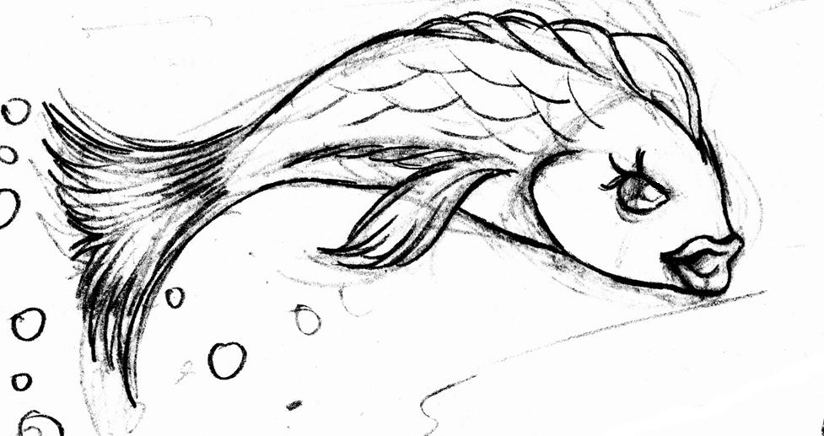

Chapter three - Melba, the crab and a lizard
Melba swam further down the creek without rest. The valley twisted and curved and the creek became deeper and wider. If you looked down at the valley from the top of the mountains, the creek would seem like a white thread. In one place, a large rock had broken off from the mountain, fallen to the bottom of the valley, and had split the water into two branches.
A large lizard the size of a hand, laid on her stomach on the warm rock. She was enjoying the sun's warmth and watching a large, round crab resting on the sand at the bottom of the water in a shallow pool and eating a frog he had caught.
Melba suddenly saw the crab, became frightened, and greeted him from afar, “Good day Sir”.
The crab glanced sideways at her and said, "What a polite fish! Come closer, little one. Come on! What are you up to?"
"I'm off to see the world," said Melba, "and I never want to be caught by you, Sir!"
"Little fish, why are you so pessimistic and scared?" asked the crab.
"I'm neither pessimistic nor afraid," answered Melba. "I speak about everything I see and understand."
"Well, then," said the crab, "please tell me what you've seen and understood that makes you think I want to capture you?"
"Don't try to trick me!" responded Melba, starring at what the crab was holding.
"Are you referring to the frog?" queried the crab. "How childish you are! I have a grudge against frogs; that's the reason I hunt them. Do you know, they think they're the only creatures in the world and that they're very lucky? I want to make them understand who is really Master in the world! So you don't have to be afraid, my dear. Come here. Come on."
As the crab talked, he was walking backwards towards Melba. His sight was so funny that she couldn't help laughing and said,
"Poor thing! You don't even know how to walk. How did you ever learn who runs the world?" forgetting her own decision not to judge others.
Melba swam away from the crab to keep a distance. A shadow fell upon the water and suddenly a heavy blow pushed the crab into the sand. The lizard had laughed so hard at the crab's expression and Melba’s words that she slipped and almost fell into the water. The crab got stuck and couldn't get out of the sand.
Melba heard another laughter and saw that a young shepherd was standing at the edge of the water watching and laughing at her and the crab. A flock of sheep and goats came up to the water and dipped their mouths in to drink. The valley was filled with the sounds of "meh meh" and "bah bah."
Melba waited until the sheep and goats had drank their water and left, then she called the lizard, "Dear lizard, I'm a little red fish who's going to search for the end of the creek. I think you're wise, so, I'd like to ask you something."
"Ask anything you want." said the lizard.
"All along the way, they've been frightening me a great deal about the pelican, the shark and the heron. Do you know anything about them?"
"The shark and the heron," said the lizard, "aren't found in this area, especially the shark who lives in the big ocean.
But it's possible that the pelican is farther downstream. Be careful that he doesn't trick you and catch you in his pouch."
"What pouch?" asked Melba interested.
"Under his throat," explained the lizard, "the pelican has a pouch that holds a lot of water. The pelican swims in the water and the fish sometimes, without realizing it, enter his pouch and then go straight into his stomach. But if the pelican isn't hungry, he stores the fish in his pouch to eat them later."
"If a fish enters the pouch, is there any way of getting out?" asked Melba.
"There's no way unless the fish rips open the pouch," answered the lizard.
"I'm going to give you a sharp stone so that if you get caught by the pelican, you can do just that."
Then the lizard crawled into a crack in the rock and returned with a very small but sharp edged stone. Melba took the stone and said:
"Dear lizard, you are so kind! I don't know how to thank you."
"It's not necessary to thank me, my dear. I have many of these stone pieces. When I have nothing to do, I sit down and split them off of the big rock and give them to smart fish like you." Laughed the lizard.
"What?" asked Melba surprised, "Have other fish passed here before me?"
"Many have passed by," the lizard replied. "They've formed themselves into a school and they give the fisherman a hard time."
"Excuse me for talking so much," said Melba, "but if you don't think I am too nosey, tell me how they give the fisherman a hard time.
"Well," answered the lizard, "they stick together. Whenever the fisherman throws his net, they get inside, pull the net with them, and drag it to the depths of the ocean."
The lizard placed her ear on the crack, listened and said, "I must excuse myself now. My children are waking up." The lizard went into the crack in the rock. Melba had no choice but to set out again.
But meanwhile there were still many questions on her mind. "Is it true that the creek flows to the ocean? If only the pelican doesn't catch me!
Is it true the swordfish enjoys killing and eating its own kind? Why is the heron our enemy?"
The smart are always modest, the weak think they rule the world. Be kind and help others. It is always good to be prepared for things that might cause problems in the future but it should not make us worry so much that we lose our positive attitude.
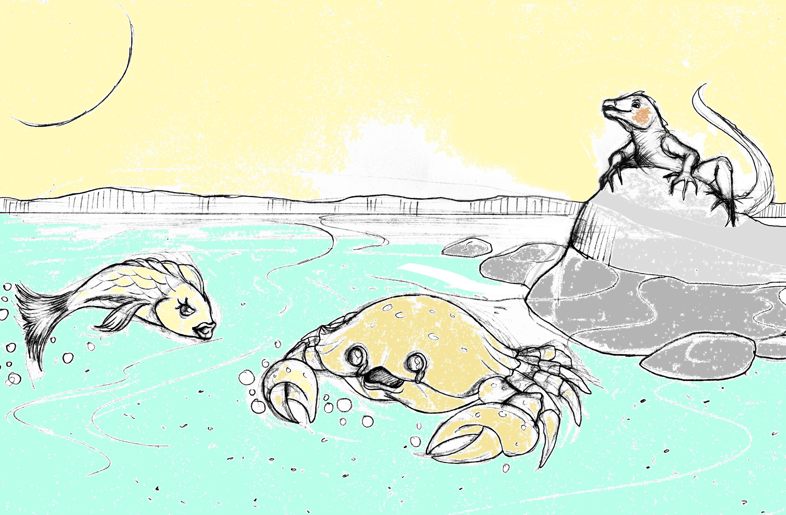

Chapter four - Melba learns from a deer
Melba continued thinking while she swam away. In every stretch of the way she saw and learned new things. Meanwhile she liked to turn summersaults, tumble down waterfalls, and swim again into deeper and wider water. Melba felt the warmth of the sun on the surface and felt stronger. At one place a deer was hastily drinking some water.
Melba greeted her, "Pretty deer, why are you in such a hurry?"
"A hunter is following me," replied the deer.
"I've been hit by a bullet….. right here!"
Melba didn't see the bullet hole, but she thought from the deer's limping that she might have been hurt.
“What did you do to the hunter that he shot you?” asked Melba.
“Nothing. I was warned since I was a little kid that this would happen sooner or later. This is what hunters do to us and there is nothing I can do about it. I was just not careful enough and got too close to the village.” cried the deer out full of fear.
Melba looked behind the deer into the forest but did not hear or see any movement.
“Are you sure the hunter is following you? Maybe you got scared by a noise and injured yourself while running through the thick brush.” suggested Melba.
“You seem not to know what humans can do to catch us. I heard they even catch fish. You better hide if the hunter comes along chasing me” warned the deer.
“Yes, I heard that fisherman want to catch us fish with nets at a place called ocean, but we fish gather and ruin their plans by pulling their nets into the deep. We fish are stronger than the fisherman.” said Melba proud.
“Nonsense,” called the dear out. “You have no clue and just believe stories others tell.”
There was suddenly movement at the edge of the water where there was a patch of cattails. A duck took off and flew over Melba and the deer. The Deer got scared and jumped away from the water.
“The hunter, I have to run or he will shoot me again.” Screamed the deer and jumped quickly into the forest.
Melba waited behind a rock for a while but nobody was to see or hear.
She wondered of what the deer had said and if the story with the fisherman was true or not.
She realized that the deer had been told that one day a hunter would be after her and she believed it so much that she was always scared of it happening, even imagining that a hunter was after her.
Melba decided to find out if the story with the school of fish fooling the fisherman is true or not by seeing it herself.
Melba swam further till she could not see any further when it got dark. She slept that night between the roots of cattails.
Being always negative can kill your dreams and create a negative picture of life. If one thinks of bad things to happen all the time, bad things will happen. Yes, bad things might happen in life even with a positive attitude. It is important to turn bad to good by learning to see the lessons life brings us in the bad as experiences to avoid the bad in the future.

Chapter five - Melba is prepared but not worried
Melba continued on her journey. At one place turtles were napping in the sun's warmth. At another place the loud calls of partridges echoed through the valley. The fragrance of the grass on the meadows was floating through the air and mixed with the water.
In the afternoon, Melba reached a spot where the valley widened and the water passed through the center of a grove of trees. There was so much water that Melba really enjoyed it. She liked the ever widening river and all that she was experiencing.
Later Melba came upon a school of tiny fish. She had not seen any other fish since leaving her mother. Several tiny fish surrounded Melba and said:
"You must be a stranger here!"
"Yes," responded Melba, "I'm a stranger. I've come from far away."
"Where do you want to go?" asked the tiny fish.
"I'm going to find the end of the creek," replied Melba.
"Which creek ?"
"This very creek we're swimming in," answered Melba.
"We call this a river," stated the tiny fish.
Melba didn't say anything.
“Are you the ones I heard about that take the fisherman’s net away by pulling it into the deep?” Melba wondered.
“No, those are our older brothers and sisters in the ocean. They are our idols. We will learn from them what it takes to fool the fisherman.” said one of the tiny fish with a proud voice.
"But tell us of yourself. You are brave. Don't you know that the pelican lives along the River?" inquired one of the tiny fish.
"Yes, I know," answered Melba.
"Do you know what a big wide pouch the pelican has?" asked another.
"I know that too," replied Melba.
"In spite of all this, you still want to go further?" exclaimed one of the tiny fish.
"Yes," said Melba, “I must go, no matter what happens."
Soon after a rumour spread among all the tiny fish that a little red fish had come from far away and wanted to find the end of the river. And the red fish wasn't even afraid of the pelican! Several tiny fish were tempted to go with Melba but didn't say anything because they were afraid of the grown-ups. Others said, "If there weren't a pelican, we would come with you. We're afraid of the pelican's pouch. We have to wait for our older brothers and sisters to come back to guide us."
“I am not afraid of the pelican. I am prepared.” said Melba with a proud chest and swam away.
Don’t be afraid to follow your dreams. You will not get anywhere if you worry about what is in the future. Be prepared but not worried of challenges along the Journey of Life. It is good to have help from others to achieve goals but do not wait for others to do the work for you.

Chapter six - Melba’s dream
A village was on the edge of the river further downstream. A few village women and girls were washing dishes and clothes in the river. Melba listened to their chatter for a while and watched the children bathing, then set off. She went on and on and on, still farther on, until night fell, then laid down under a rock to sleep. Melba woke in the middle of the night and saw the moon shining into the water and lighting up everything. Melba liked the moon very much. On nights when the moon shone into the water, she longed to creep out from under the vegetation and speak with the moon. But Mother would always wake up, pull her back under the cover, and make her go to sleep again.
Melba looked up at the moon and said "Hello, my lovely moon!"
"Hello, Little red Fish. What brings you here?" replied the moon with a soft voice.
"I'm traveling around the world." replied Melba.
"The world is very big," said the moon. "You can't travel everywhere."
"That's okay," said Melba. "I'll go everywhere I can."
"I'd like to stay with you till morning," said the moon, "but a big black cloud is coming toward me to block out my light."
"Beautiful moon! I like your light so much. I wish you'd always shine on me." smiled Melba.
"My dear fish, the truth is, I don't have any light of my own. The sun gives me light and I reflect it to the earth. Tell me, have you heard that humans did fly up and land on me?" asked the moon.
"That's impossible," said Melba surprised.
"It's a difficult task," said the moon, "but whatever humans want they ..."
The moon couldn't finish her sentence. The dark cloud had arrived and covered her face.
The night became dark again, and Melba was alone. She looked at the darkness in surprise and amazement for several seconds, then crept back under the rock and fell asleep.
Melba dreamt about what the moon had said; that humans did what seemed impossible to her; flying to the moon. She wished for a short moment to be human and do the same. Maybe humans do know the answer too many things but why than could fish in the ocean drag the fisherman’s net into the deep? Maybe she could fly to the moon too!
Melba woke up early in the morning and thought about her dream. She thought that if the dream was true she could reach her goals like the humans did with landing on the moon. She could do things that she dreamt of but never thought possible too, even without knowing how at the very moment. She could finally find the answer to her question: What is at the end of the River that was fed by the Creek.
You can achieve your goals and reach your dreams even if you do not know how at the moment. The answers to the how will be given as you continue along the Journey. Determination and steady thought about the dream mixed with action will bring you closer and closer to what you envisioned.

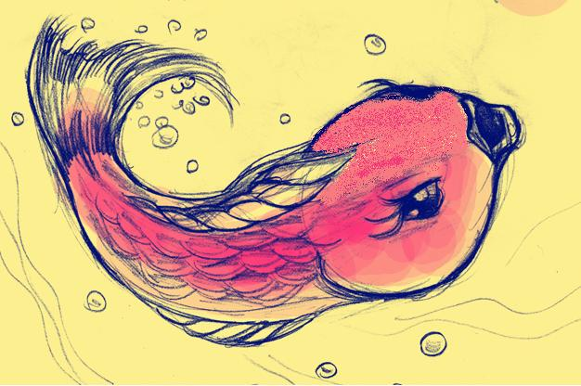

Chapter seven - Melba faces the Pelican
Melba heard all of a sudden overhead several tiny fish chattering. When they saw that she was had discovered them, they said in one voice:
"Good morning!"
Melba recognized them right away and said, "Good morning! You followed me after all!"
"Yes," answered one of the tiny fish, "but we're still afraid."
"The thought of the pelican just won't go away," said another.
"You worry too much," said Melba. "One shouldn't worry all the time. Let's start out and our fears will vanish completely."
But as they were about to set out, they felt the water all around them rise up and a lid was placed over them. It was dark everywhere and there was no way to escape. Melba immediately realized that they had been caught in the pelican's pouch.
"My friends," said Melba with a small voice, "we've been caught in the pelican's pouch, but there's a chance to escape."
All the tiny fish began to cry. One of them said, "There's no way to escape! It's your fault since you influenced us and led us into this."
"Now he's going to swallow us all, and then we'll die," said another.
Suddenly the sound of frightening laughter twisted through the water. It was the pelican. He kept on laughing and said, "What tiny fish I've caught! Ha. Ha. Truly, my heart bleeds for you. I don't want to swallow you! Ha, Ha ..."
The tiny fish began pleading, "Your Excellency, Mr. Pelican! We've been hearing about you for a long time. If you'd be so kind as to open your beak a little so that we might jump out, we'll always be grateful to you."
"I don't want to swallow you right now," said the pelican. "I've some fish stored. Look below."
Several large and tiny fish were scattered on the bottom of the pouch.
"Your Excellency, Mr. Pelican!" cried the tiny fish, "we haven't done anything. We're innocent. This little red fish has led us astray ..."
"Cowards!" called Melba disappointed, "are you crying like this because you think this dishonest bird is merciful?"
"You don't know what you're saying," said the tiny fish. "Just wait and see ... His Excellency, Mr. Pelican, will pardon us and swallow you!"
"Of course I'll pardon you," said the pelican. "But on one condition."
"Your condition, please, sir!" begged the tiny fish.
"Strangle that nosy red fish, and then you'll get your freedom."
Melba moved aside and said to the tiny fish,
"Don't agree! This deceitful bird wants to turn us against each other. I have a plan ..."
But the tiny fish were so intent on saving themselves that they couldn't think of anything else. They surrounded Melba who was sitting near the back of the pouch and talking slowly.
"Cowards! Whatever happens, you've been caught and don't have a way to escape. And you're not strong enough to hurt me."
"We must strangle you," said the tiny fish."We want freedom!"
"You've all lost your senses," said Melba. "Even if you strangle me, you won't escape. Don't fall for his tricks..."
"You're talking like this just to save yourself," said the tiny fish. "Otherwise you wouldn't think of us at all."
"Just listen," said Melba, "and I'll explain. I'll pretend I'm dead. Then, we'll see whether or not the pelican will free you. If you don't agree to this, I'll kill all of you with this sharp stone or I rip open the pouch and escape while you ..."
"Enough!" interrupted one of the fish. "I can't stand such talk anymore. Oh, huhuh ...oh, huhuh ...oh huhuh ..."
"Why did you ever bring this weakling along?” asked Melba upon seeing him cry. She then took out the sharp stone and held it in front of the tiny fish. Helpless, they agreed to her suggestion. They pretended to be fighting with each other. Melba pretended to be dead. The others went forward and said, "Your Excellency, Mr. Pelican, we strangled the nosey red fish ..." "Good work!" laughed the pelican. "Now, as a reward, I'm going to swallow all of you alive so that you can have a nice stroll in my stomach!"
The tiny fish never had a chance. Quick as lightening they passed through the pelican's throat and were gone.
At that very instant, Melba drew the sharp stone, split open the wall of the pouch with one slice just wide enough for herself and fled. The pelican cried out in pain and smashed his head on the water but he couldn't follow after Melba.
Those who think negative and think bad upon others will fall victim to their own negativity. There is always a solution to a problem or situation.

Chapter eight - Melba reaches the ocean
Melba went on and on and still farther on until it was noon. The river had passed through the mountains and valleys and now was flowing across a level plain. Several other smaller rivers had joined it from the right and the left, increasing its water significantly. Melba was enjoying the masses of the water.
Melba realized soon that the water had no bottom. She swam this way and that way and didn't touch ground anywhere. There was so much water that the she got lost in it! No matter how far she swam, still the water was endless. She swam, deeper and deeper to look for the bottom. She met on her way a school of fish, thousands and thousands of them.
"Friend," said Melba to one of them, "I'm a stranger. I've come from far away. Are you all the older brothers and sisters of the little fishes I met upstream?”
The fish called his friends and said, "Look! Another ..." Then replied to Melba, "Friend, welcome to the ocean. Yes we are the ones you think we are."
Melba asked excited, “Than you know what this place is?"
All fish answered together, "All rivers and creeks flow here, except some which flow into swamps, welcome to the Ocean. You can join our group anytime you wish,"
Melba was happy to have reached the ocean and said, "I'd like to travel around first, then I'll come join your group. I'd like to be with you the next time you pull down the fisherman's net."
"You'll get your wish soon," answered one of the fish. "Now go explore. But if you swim to the surface, watch out for the Heron who isn't afraid of anyone these days. She doesn't stop bothering us till she has caught four or five of us a day. And did you hear about the shark who can slice through a school of fish in no time? "
“Yes, I heard about the shark. Can he harm a single tiny fish like me?” Melba wondered.
“No you are safe unless you are a big shiny fish or in a school together with others like we are.” said the other fish.
Melba wondered about their reply. She thought that swimming along with others and being big in size means to have security but this seemed not always be true. But this was obviously not true when it came to face the shark.
It is not always the best to do what the many others do. It can be a blessing or a distraction. Always think critical about things and do not be shy to do or say things that are outside of the norm. It does not matter how tiny you think you are, sometimes tiny things move more than big things.

Chapter nine - Melba and the Heron
Melba then left the group of ocean fish and began swimming to the surface of the ocean. A warm sun was shining. Melba enjoyed feeling the sun's bright rays on her back. She was swimming calm and happy on the surface of the sea and thinking, "Death could come upon me very easily now. But as long as I'm able to live, I shouldn't go out to meet death.
Of course, if someday I should be forced to face death-as I shall-it doesn't matter. What does matter is the influence that my life or death will have on the lives of others . . ."
Melba wasn't able to pursue these thoughts. A heron dived down, scooped her up and carried her off.
Caught in the Heron's long beak, Melba kicked and waved but couldn't get free. The heron had grabbed her waist so tightly that her life was fading away. After all, how long can a little fish stay alive out of water?
"If only the heron would swallow me this very instant," thought Melba hopeless, "then the water and moisture inside her stomach would prevent my death at least for a few minutes."
Melba addressed the Heron with this thought in mind. "Why don't you swallow me alive? I'm one of those fish whose body becomes full of poison after death."
The Heron didn't reply. He thought, "Oh, a tricky one! What are you up to? You want to get me talking so you can escape!"
Dry land was visible in the distance. It got closer and closer.
"If we reach dry land," thought Melba, "all is finished."
"I know you want to take me to your children," said Melba, "but by the time we reach land, I'll be dead, and my body will become a sack full of poison. Why don't you have pity for your children?"
"Precaution is also a virtue!" thought the heron. "I can eat you myself and catch another fish for my children. . . but let's see . . . could this be a trick? No, you can't do anything."
As the Heron thought she noticed that the red fish's body was limp and motionless. "Does this mean you're dead," thought the heron. "Now I can't even eat you! I've ruined such a soft and delicate fish for no reason at all!"
"Hey little one!" he called Melba. "Are you still half alive so that I can eat you?"
But she didn't finish speaking because the moment she opened her beak, Melba jumped and fell down.
The heron realized how badly she'd been tricked and dived after her. Melba darted through the air like lightening. She had lost her senses from thirst for water and she opened her dry mouth into the moist wind of the ocean.
But as soon as she splashed into the water and took a new breath, the heron caught up and this time swallowed her so fast that she didn't understand what had happened.
Melba only sensed that everywhere was wet and dark. There was no way out. The sound of crying could be heard. When Melba`s eyes had become accustomed to the dark, she saw a tiny sea horse crouched in a corner, crying. He wanted his mother. Melba approached and said:
"Little one! . . .Get up! Think about what we should do. What are you crying for? Why do you want your mother?"
"You there . . .Who are you?" responded the tiny sea horse. "Can't you see? ...I'm ...dying. O, I ...oh, I...oh, oh ...mama ...I ...I can't come with you to see how the fish pull the fisherman's net to the bottom of the ocean any more ...oh, oh ...oh, oh!"
"Enough, there!" said Melba. "You'll disgrace all sea creatures."
After the tiny sea horse had controlled his crying, Melba continued, "I want to teach a lesson to the heron and find peace of mind for all fish. But first, I must send you outside so that you don't ruin everything."
"You're dying yourself," replied the tiny sea horse. "How can you kill the heron?"
Melba showed the sharp stone. "From right inside here, I'm going to rip open her stomach. Now listen to what I say. I'm going to start tossing back and forth in order to tickle the heron. As soon as she opens her mouth and begins to laugh, you jump out."
"Then what about you?" asked the tiny sea horse.
"Don't worry about me. Swim fast away once you jump out of the Herons throat.”
Melba stopped talking and began tossing back and forth and tickling the heron's stomach. The tiny sea horse was standing ready at the entrance of the heron's stomach. As soon as the heron opened her mouth and began to laugh, the tiny sea horse jumped out and fell into the Ocean. But no matter how long he waited, there wasn't any sign of Melba. Suddenly, he saw the heron twist and turn and cry out.
Then he began to beat his wings and fall down. He splashed into the water. He beat his wings again, than all movement stopped.
There is always a solution. Never give up, even if it feels like the worst possible happened. Always search for a way to avoid the worst but when life brings you a bad situation be hopeful and have courage. The sun rises after every night and the rain stops for sure to give way to the sun.

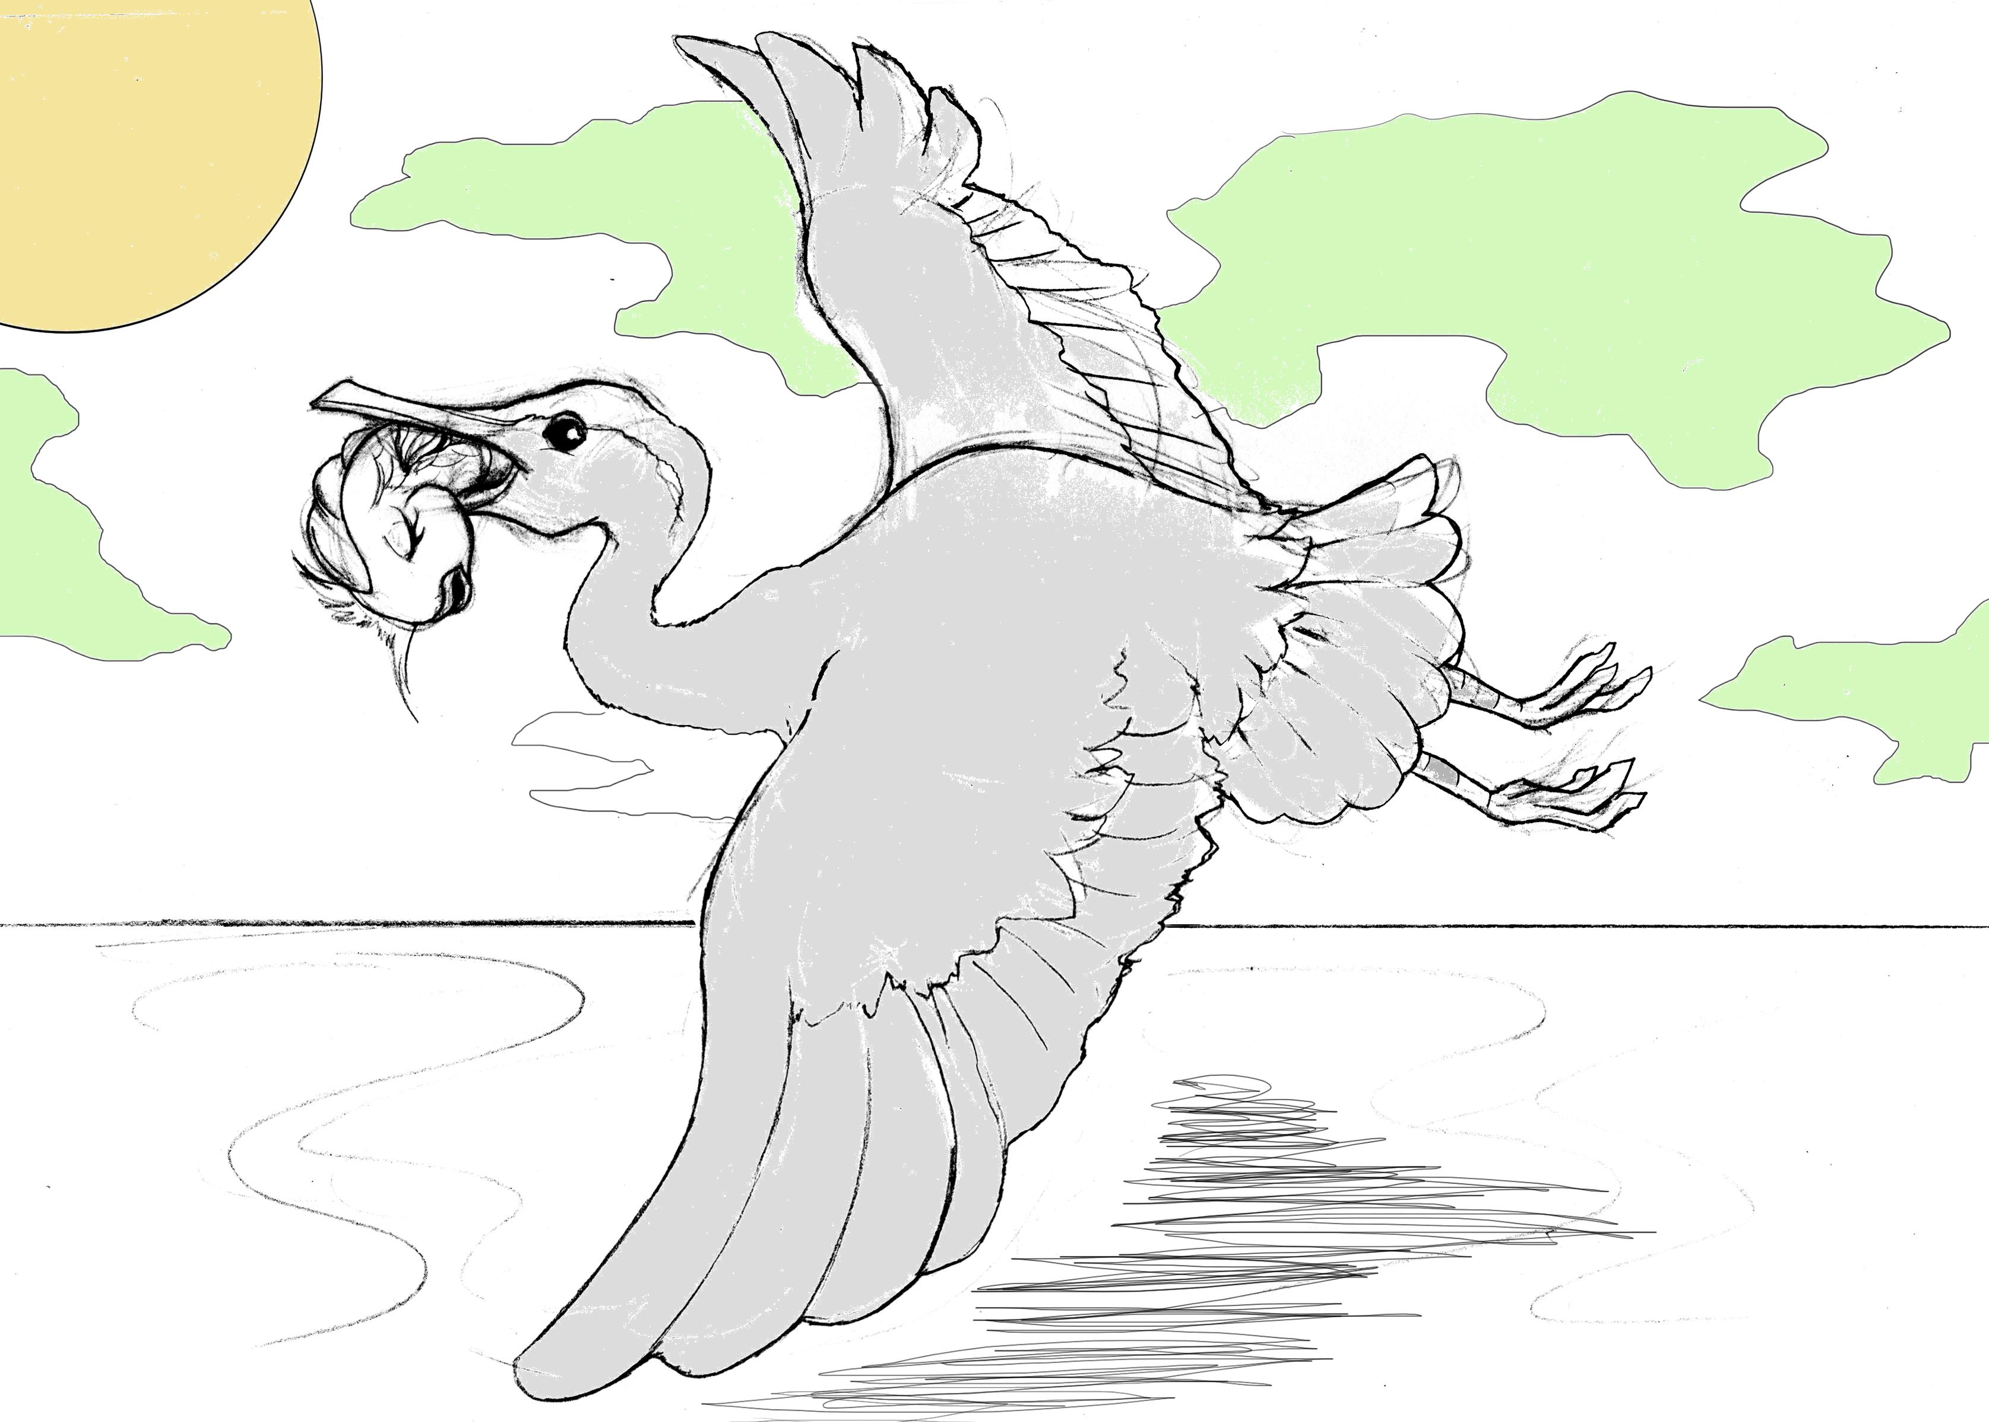

Chapter 10 – Melba finds her new world
But where was Melba? She was nowhere to be found. The little Sea horse waited and waited but no sign of Melba. He little seahorse swam as fast as it could to the school of fish and told them how Melba helped him and how the Heron was no more able to threaten them.
“I worry Melba couldn’t make it”, said the tiny sea horse with a sad voice.
“It does not mean anything”, called the school of fish out together. “We will search for her together, let’s go.”
The school of fish darted fast towards where the small sea horse had told them the heron landed. They swam deeper and deeper, even deeper than ever before, searching for Melba.
Meanwhile, Melba had dropped out of the heron and sank deep to the ocean floor where she laid for a while. She dreamt of her home, her mother and the Journey she had behind her. She dreamt of how she had overcome many struggles and how she was pulling with many other fish the fisherman’s net into the deep waters.
She woke slowly up from her deep sleep and felt the peace and quiet around her. This made her feel peaceful and happy.
“Am I dead now?” wondered Melba still numb. I feel like I am in a new world.”
“Ha..Haha..Ha..Haha, are you seasick?” called a high voice out of the dark.
“Who are you?” asked Melba worried as she could not see anybody.
“It’s me the Dolphin. You must have been lost or totally crazy swimming so deep down here to have a nap.” tooted the Dolphin, as he swam closer.
Melba saw an elegant long stretched strong Dolphin with a big smile sticking her nose underneath her and lifting her. That tickled Melba and sent her flying in a loop off the ocean floor.
“You seem to be very friendly. I heard about your strength and wisdom before.” laughed Melba.
“Yes, thank you for calling me that. I learned how to have always a good attitude and be uplifting to others. I love all sea creatures and see the good in all of them. That is why everybody likes me.” nodded the Dolphin. “Let us quickly find your school of fish. Down here is not safe as the Shark will pick you up as lunch if you stay down here.”
“Shark, I have heard about the Shark. Is he really as bad as they say?” wondered Melba.
“The Shark is the pessimist, the one who always thinks about himself and has a frown on his face. He is always negative and does not hesitate to show his dislike and bad mood to others. That is why he swims almost always alone, unless he finds other Sharks to exchange his negative stories and gossip.” said the Dolphin while swimming back flips.
“So it is better to stay away from the Shark or he makes me become negative and grow longer teeth too.” worried Melba, trying to sound funny while looking frightened around her into the surrounding dark.
The Dolphin put her nose under Melba and lifted her onto her back taking her up where there was more light and safe. It was there where the school of fish found Melba and surrounded her happily.
“The Dolphin found you. You are lucky. He is our teacher and we learned many positive things from him.” chanted all fish excited.
“Including the trick with the fisherman’s net?” questioned Melba.
“Yes. You can learn from the others, now that you have found your school of fish. You know now what it takes to survive in the ocean. You learned many things along your Journey. Welcome to your new world, your future home.” called the Dolphin and swam away with a few quick strides.
The old fish finished her tale and said to her 12,000 children and grandchildren, "Now it's time to sleep, children. Go to bed."
"Grandmother!" called all the children and grand-children, "You didn't say if that tiny red fish was able to learn to fool the fisherman too and if she went back home to tell her stories to her mom and friends back home."
"We'll leave that for tomorrow night," said the old fish. "Now, it's time for bed. Goodnight."
Eleven thousand, nine hundred and ninety-nine little fish said goodnight and went to sleep. The grandmother fell asleep too.
But as hard as she tried one little red fish couldn't go to sleep. All night long she thought about Melba and the creek....................
The story comes to an end but your journey into life continues. I know that this story will disappear amongst the many things that you experience every day, the daily routines, the school, the playing with friends, homework and many many more things you do. But I hope you will remember to stay positive and courageous in whatever you do and maybe you will remember Melba and her story whenever you face difficulties and she will give you hope to never give up. Life is a wonderful Journey and you are here to explore, discover and shape what we call our world. Go ahead now and follow your dreams. May you be blessed on your Journey.
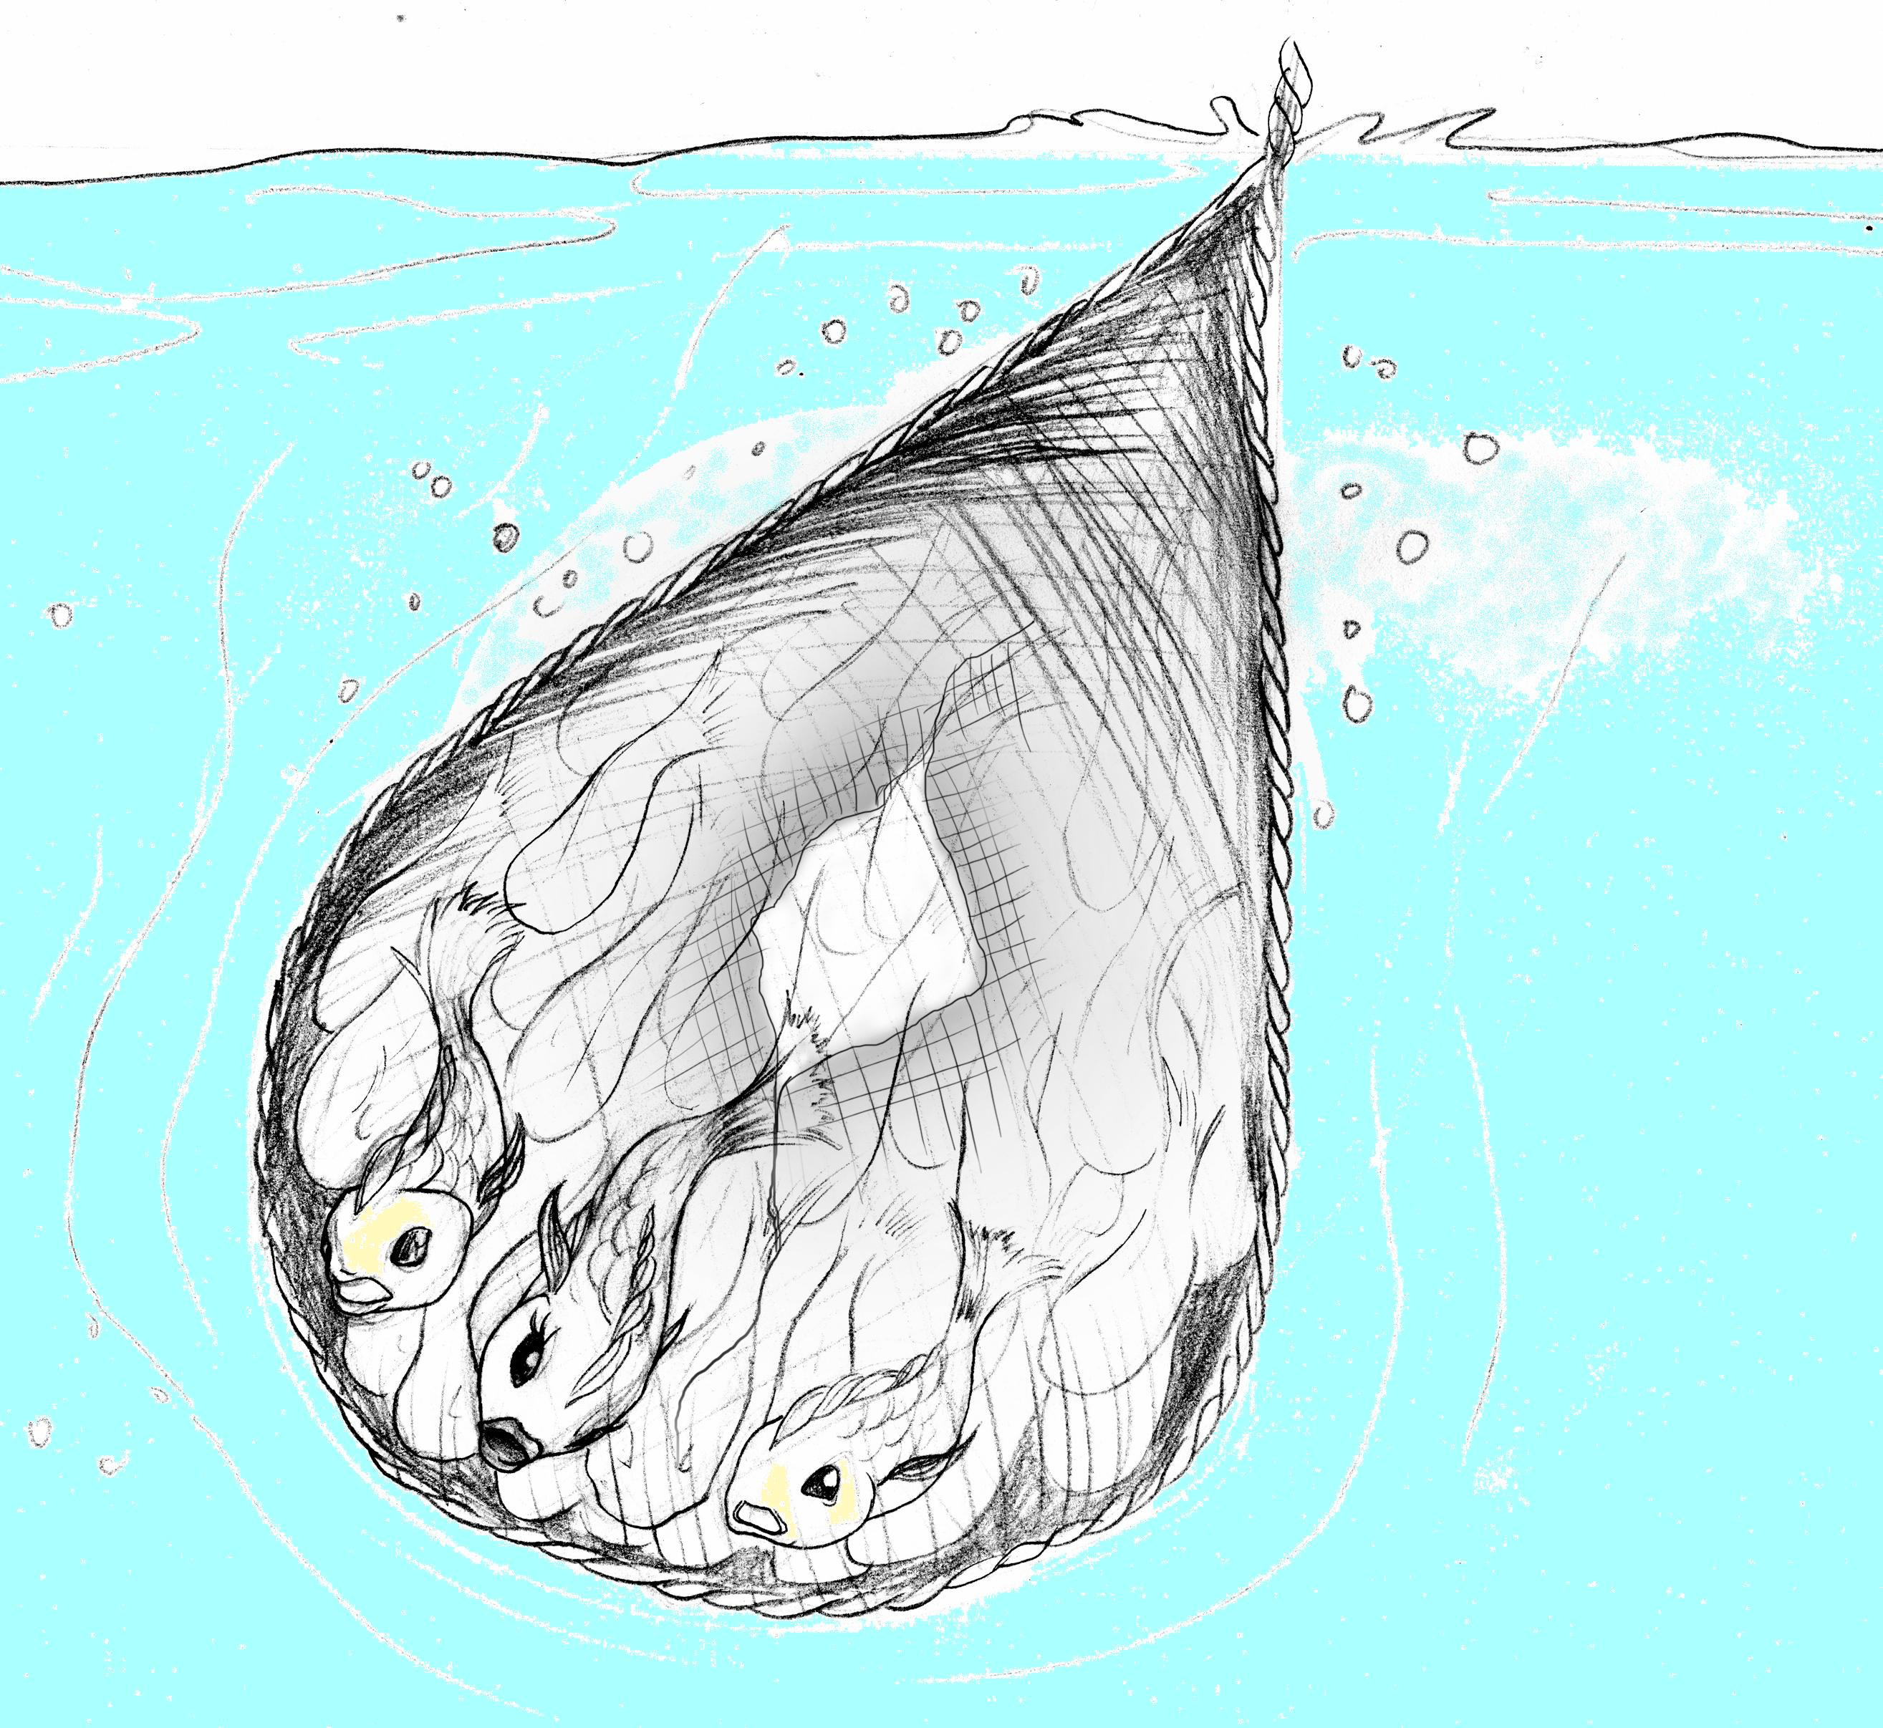
The purpose of the story
This book is one of the books in the Kids Personal Development Series.
The Kids Personal Development Series is a Series of books created around stories to bring the well published principles of personal development closer to kids. This principles are taken from books like “Think and get Rich” by Napoleon Hill, “Attitude is everything” by Jeff Keller, “Magic of Thinking big” by David J Schwartz and many more that help to change ones perspective of life and encourage to have a positive attitude.
The information and messages contained in those books are important to plan, pursue and reach goals in life. Many have fulfilled their life dreams with the thought methods. Many prospered and overcame challenges learning from these books.
Our Society has changed and we are confronted earlier in life with life challenges. The realities of economy like unemployment of parents, Social challenges like bullying in school and family challenges like divorce of parents are just 3 examples of what kids might have to overcome. They are unprepared, inexperienced and often alone in dealing with such challenges.
Although the Kids personal development Series books are not claiming to be able to solve all problems and challenges, they can give an easy to understand essence of the personal development strategies and a motivational boost in form of stories. The so called self-help books or personal development books mentioned before are too long and might be too hard to understand for kids.
I encourage parents to read the Kids Personal Development books too and discuss different issues in life with their kids. One to help them to deal with their challenges and secondly to spend highly needed valuable time with them. I encourage parents further to read themselves Personal Development books and strive for a change in our society, away from the pessimistic out view for the future, negative attitudes and bad habits towards positive attitudes, optimism and planned prosperity. We owe it to our children, who look up to us and take an example on us.
Stay tuned for further Kids personal development books that will be published in near future.
Thank you for your interest.

